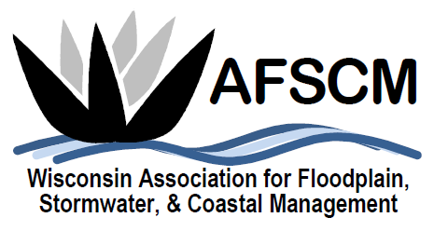
QUARTERLY BOARD MEETING
Tuesday, December 3, 2019 at 3:30 pm

LOCATION: Conference Call Number: 662-778-8081
Conference Code: 704701694#

AGENDA

- ATTENDANCE
- APPROVAL OF SEPTEMBER 3, 2019 BOARD MEETING MINUTES
- TREASURER’S REPORT
- 2019 ANNUAL CONFERENCE RECAP

- FUTURE ANNUAL CONFERENCES
  - 2021 – Joint Conference with MN in La Crosse
  - Planning reference document

- COMMITTEE REPORTS
  - Awards Committee – Laura Herrick
  - Education – Terry Tavera
  - Legislative Committee – Dave Fowler
  - Membership – Kristen Belan
  - Newsletter – Betsy Powers
  - Scholarship – Katie Sommers
  - WDNR Liaison Floodplain Management – Michelle Staff
  - Website – Ryan VanCamp

- IAFSM RAPID ASSISTANCE FLOOD TEAM
- ASFPM – Katie Sommers

- STRATEGIC PLANNING UPDATES

- OTHER BUSINESS

