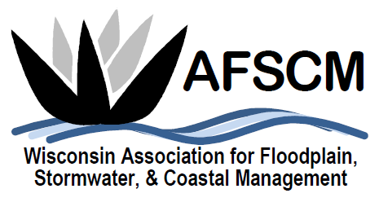
QUARTERLY BOARD MEETING
Tuesday, June 4, 2019 at 3:30 pm

LOCATION:
Global Water Center
(The Jones Board Room)
247 W. Freshwater Way Milwaukee, WI

AGENDA

- ATTENDANCE
- APPROVAL OF MARCH 20, 2019 BOARD MEETING MINUTES
- TREASURER’S REPORT
- 2019 ANNUAL CONFERENCE
  - Planning Committee & Board Attendance
  - Volunteers needed
  - Pricing for conference

- FUTURE ANNUAL CONFERENCES
  - 2021 – Joint Conference with MN in La Crosse?
  - Planning reference document

- Elections held at Annual Conference this Year
  - Open positions and potential nominees

- COMMITTEE REPORTS
  - Awards Committee – Laura Herrick
  - Education – Terry Tavera
  - Legislative Committee – Dave Fowler
  - Membership – Kristen Belan
  - Newsletter – Betsy Powers
  - Scholarship – Katie Sommers
  - WDNR Liaison Floodplain Management – Michelle Staff
  - Website – Ryan VanCamp

- IAFSM RAPID ASSISTANCE FLOOD TEAM
- ASFPM – Katie Sommers
  - Update

- STRATEGIC PLANNING UPDATES
  - Board job descriptions

- OTHER BUSINESS

