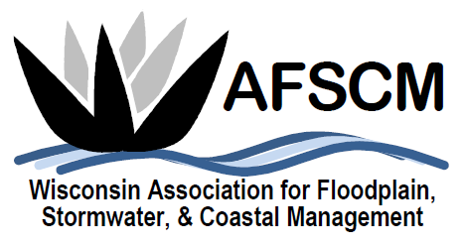

QUARTERLY BOARD MEETING
Tuesday, March 5, 2019
3:30 pm

LOCATION: Conference Call Number: 515-739-1460
Conference Code: 534673

AGENDA

- ATTENDANCE
- APPROVAL OF DECEMBER 4, 2018 BOARD MEETING MINUTES
- TREASURER’S REPORT
- 2019 ANNUAL CONFERENCE
  - Planning Committee & Board Attendance
  - Volunteers

- FUTURE ANNUAL CONFERENCES
  - Planning reference document – Cindi available to review

- COMMITTEE REPORTS
  - Awards Committee – Laura Herrick
  - Education – Terry Tavera
  - Legislative Committee – Dave Fowler
  - Membership – Kristen Belan
  - Newsletter – Betsy Powers
  - Scholarship – Katie Sommers
  - WDNR Liaison Floodplain Management – Michelle Staff
  - Website – Ryan VanCamp

- IAFSM RAPID ASSISTANCE FLOOD TEAM
- ASFPM – Katie Sommers
  - Update
  - Annual Report
    - What are your chapter’s best accomplishments this year? What are you most proud of? This can be related to training and content, your conference, how you manage your chapter, or anything else. Try to think of something other chapters and ASFPM will benefit from hearing about.
    - What challenges has your chapter faced this year? Again, think about something that may be useful for other chapters and ASFPM to hear or for which they might have good advice.
    - What could ASFPM do to make your chapter membership more valuable? What assistance, resources, or services could ASFPM provide chapters to enhance their experience?
  - Chapter Meeting Topics at Annual Conference
- STRATEGIC PLANNING UPDATES
  - Board job descriptions

- OTHER BUSINESS

