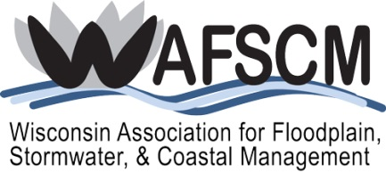
SCHOLARSHIP APPLICATION FORM
for
ASFPM’S 42nd Annual National Conference
“Managing Floods Where the Mountains Meet the Desert”
June 17-21, 2018
Phoenix, Arizona

You must be a current WAFSCM member to apply!
Name:
Title:
Employer:
Address:
City/State/ZIP:
Phone:
Email:

Scholarship application for cost of early registration (before April 17, 2018):
 | ASFPM Member | $685 |  | ASFPM Non-Member | $870

Scholarship application for cost of workshops, tours, and events (before April 17, 2018):
Workshop/Tour: |  | Cost:

Number of nights of lodging (up to $199 plus tax), not to exceed four nights:

Total scholarship requested (not to exceed $2,000): $

How will attending this conference assist you in your present position?

Why do you want to attend this conference and what do you hope to gain by attending?

Certified Floodplain Manager (CFM): |  | Yes |  | No

Years you have been a WAFSCM member: |  |  |  |  |  |  |  |  |  | 2002 |  | 2003 |  | 2004
 |  | 2005 |  | 2006 |  | 2007 |  | 2008 |  | 2009 |  | 2010 |  | 2011
 |  | 2012 |  | 2013 |  | 2014 |  | 2015 |  | 2016 |  | 2017 |  | 2018

Describe any past involvement you have had with WAFSCM:

Check which WAFSCM activities you are willing to participate in to support the association:
Participate on standing committee(s):
Stormwater Management
Floodplain Management
Coastal Management
Membership
Awards
Annual Conference
Website
Newsletter
Education
Provide support in workshops or other training events
Other (explain)
If you are awarded this scholarship, you are expected to register and attend the three-day conference at a minimum (Tuesday through Thursday). The scholarship will reimburse you for the general registration cost; any ASFPM workshops and field tours you register for; and up to four nights of lodging, not to exceed $2,000 total. You are responsible for your own transportation and per diem. After attending the conference, you will need to complete a Scholarship Reimbursement Form, attach receipts, and mail to WAFSCM for reimbursement. You will be provided the form upon notification of scholarship award. In addition, you will be required to write an article for the next WAFSCM Newsletter regarding your experience at the conference or another related topic.

Submit to Katie Sommers, katie.sommers@wisconsin.gov, no later than March 19, 2018.

