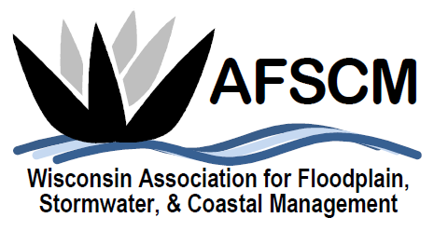

BUSINESS MEETING AGENDA
Thursday, November 8 , 2018
Ingleside Hotel, Pewaukee, WI
8:00 am

AGENDA

- Introduction – Laura Rozumalski, Chair

- Approval of 2017 Business Meeting Minutes – Kalahari Convention Center, Wisconsin Dells, WI

- 2018 Year in Review & Future Considerations

  - Treasurer’s Report
  - Twilight Presentation and Summer Social Events
  - Upcoming Board Meetings
  - WAFSCM 2019 Conference, October 23-24, 2019 at Central Wisconsin Convention & Expo Center, Rothschild (Wausau), WI
  - WAFSCM Strategic Planning
  - Future Webinars
  - Committee Needs

- Committee Reports

  - Annual Conference Committee – Megan Bender, Laura Rozumalski
Awards
  - Committee – Laura Herrick
  - Education Committee – Megan Bender, Laura Rozumalski

  - Membership Committee – Kristen Belan

  - Website Committee – Ryan Van Camp
  - Newsletter Committee – Betsy Powers
  - Scholarship Committee – Katie Sommers

  - Legislative Committee – Dave Fowler
  - WDNR Liaison Floodplain Management Committee – Michelle Staff

- Nominations for Executive Committee

- Other Business

- Next Business Meeting – October 23, 2019

